**Noise cancellation using spectral gating in python**

***Author***: *Nijat Hamidov L2, CS-19 Group-1*

***Supervisor***: *Prof. Javid Khalilov,* [*javid.khalilov@ufaz.az*](mailto:javid.khalilov@ufaz.az)

***Submission Date***: *12/11/2021*

Table of Contents

Abstract 1

Used Libraries 2

Reading the original test.wav file 2

Preparing noise for subsequent imposition 3

Rectangular wave before IFFT 4

Getting Noise (Rectangular wave after IFFT) 4

Imposing noise to the signal 5

Denoising modified signal 6

An STFT is calculated over the noise audio clip 7

Statistics are calculated over SFFT of the the noise (in frequency) 8

A threshold is calculated based upon the statistics of the noise (and the desired sensitivity of the algorithm) 8

An FFT is calculated over the signal 8

Obtaining the value of the mask and creating smoothing filter 8

9

A mask is determined by comparing the signal FFT to the threshold 9

References*:* 10

# Abstract

One of the main techniques that can be applied to reduce background noise at low level pitch is by using the noise reduction algorithm called *Fourier analysis1*. The "frequency spectrum" of the sound is determined by locating the spectrum of pure tones that make up the background noise in the selected quite sound segment. That forms a fingerprint of the static background noise in the given sound file. When the noise is reduced from the sound as a whole, the algorithm finds the frequency spectrum of each short segment of sound. Any pure tones that aren't sufficiently louder than their average levels in the fingerprint are reduced in volume by using the general technique called *spectral gating2*. The first pass of noise reduction is done over just noise. For each windowed sample of the sound, we take a *Short-time Fourier Transform (STFT)3* using a Hann window and then statistics, including *the mean power*, are tabulated for each frequency band.

# Used Libraries

All of the code below were run in *jupyter notebook* with imported *IPython* module and enabled *%matplotlib inline* magic. Reading the original test.wav file was accomplished using the *scipy.io wavfile module*. Plotting the graphs of signal and noise along with the spectrum image was done by using *matplotlib’s pyplot* module. All the numerical computations on arrays was provided by *numpy* library and its functions except for the few one (e.x for short-time Fourier transformation) which were used from *librosa* library.

# Reading the original test.wav file

**wav_loc = "test.wav"  
rate, data = *wavfile.read*(wav_loc)**  
print(type(data)) # nd.array  
print(data.ndim) # Data is 1-D array for 1-channel WAV  
print(data.size) # 200542  
  
# Standard 44.1 kHz sample rate for 16-bit wav file  
print(rate) # 44100  
  
# Assuming that the wav-file is 16 bit integer, the range is [-32768, 32767],  
# thus dividing by 32768 (2^15) will give the proper twos-complement range of [-1, 1]  
  
**data = data / 32768**

After reading test.wav file its data and sampling rate was stored in *data* and *rate* variable, respectively. Plot of the *data* variable which represents the wave for test.wav file is plotted on *Figure 1.1 .*

***Figure 1.1***

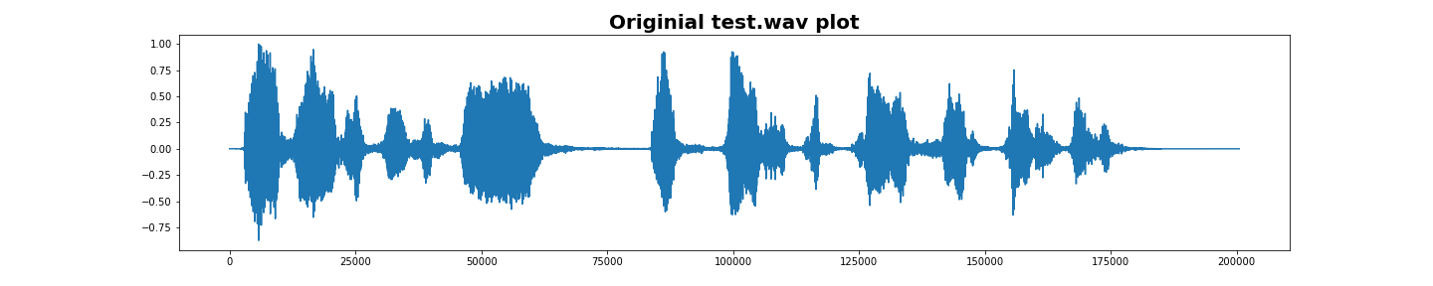

# Preparing noise for subsequent imposition

After that the noise will be prepared from rectangular wave which in turn was transformed using inverse Fourier transformation. For that two function were used.

## Rectangular wave before IFFT

def **band_limited_noise(min_freq, max_freq, samples=1024, samplerate=1):**  
# Sample spacing (inverse of the sampling rate) parameter 1 / samplerate

sample spacing is in seconds

# Array of length n containing the absolute values of sample frequencies.  
 **freqs = np.abs(np.fft.fftfreq(samples, 1 / samplerate))**

# frequency unit is in cycles/second

**f = np.zeros(samples) # 1D array of 200542 zeros**

# Rectangular wave to be transformed **f[np.logical_and(freqs >= min_freq, freqs <= max_freq)] = 1**

return **fftnoise(f)**

Before returning transformed sampled noise **band_limited_noise** functions will create a rectangular wave (*Figure 1.2*) which itself will transformed using IFFT by the **fftnoise** function.

***Figure 1.2***

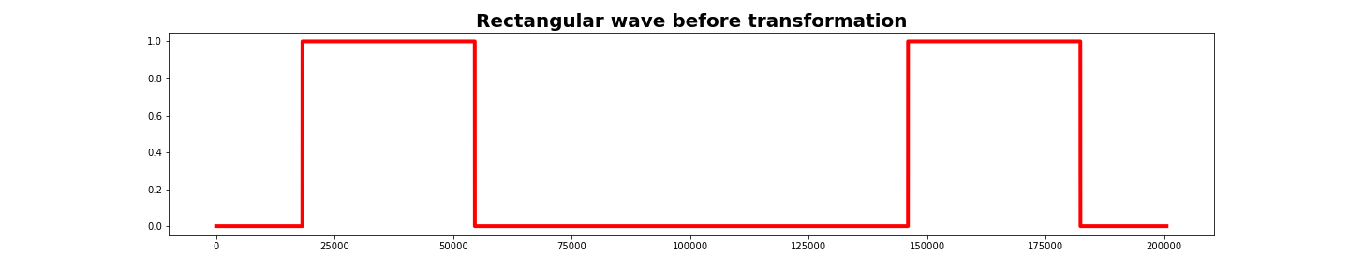

## Getting Noise (Rectangular wave after IFFT)

def **fftnoise(f):  
 # array of complx numbers with size len(data)=200542  
 f = np.array(f, dtype="complex")**

**Np = (len(f) - 1) // 2  
 phases = np.random.rand(Np) * 2 * np.pi**

**# e^(iwt) = cos(wt) + i*sin(wt)  
 phases = np.cos(phases) + 1j * np.sin(phases)  
 f[1 : Np + 1] *= phases  
 f[-1 : -1 - Np : -1] = np.conj(f[1 : Np + 1])**

# Applying IFFT  
return **np.fft.ifft(f).real**

Applying IFFT gives the noise (*Figure 1.3*) which can be imposed to our original signal (test.wav). **Note:** noise array will be multiplied by 10 in order to increase amplitude.

***Figure 1.3***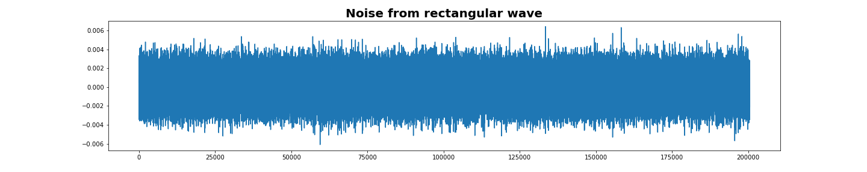

# Imposing noise to the signal

**noise_len = 2 # seconds**

**# multiplied by ten for amplitude to be 1 order high  
noise = band_limited_noise(min_freq=4000, max_freq = 12000, samples=len(data), samplerate=rate)*10**

**# get two seconds of the clip with sampling rate=44.1kHz  
noise_clip = noise[:rate*noise_len]**

**# Adding noise  
audio_clip_band_limited** = data+noise

Adding noise to the original signal has the effect of thickening the graph of the original signal. The modified original signal is show on *Figure 1.4* .

***Figure 1.4***

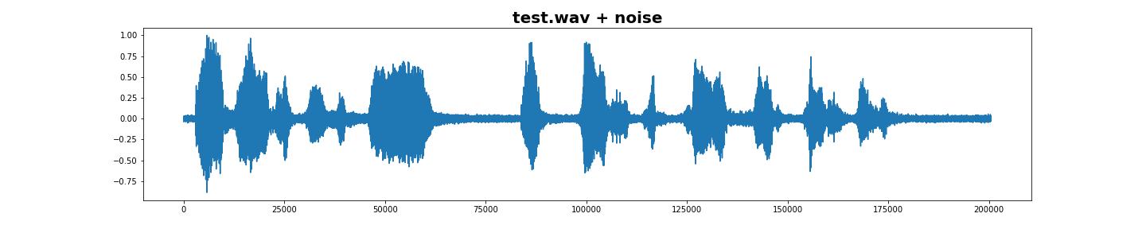

# Denoising modified signal

After modifying original wave file the first thing in order to remove imposed noise is to calculate apply Short-time Fourier Transformation over the noise audio clip. There will be needed some additional functions given below to do STFT over the noise clip. Given that functions from librose.core module, spectral gating algorithm’s steps are followed in order to reproduce the original data.

***Additional functions***

**import time**

**from datetime import timedelta as td**

**def _stft(y, n_fft, hop_length, win_length):**

**return librosa.stft(y=y, n_fft=n_fft, hop_length=hop_length, win_length=win_length)**

**def _istft(y, hop_length, win_length):**

**return librosa.istft(y, hop_length, win_length)**

**def _amp_to_db(x):**

**return librosa.core.amplitude_to_db(x, ref=1.0, amin=1e-20, top_db=80.0)**

**def _db_to_amp(x,):**

**return librosa.core.db_to_amplitude(x, ref=1.0)**

**def plot_spectrogram(signal, title):**

**fig, ax = plt.subplots(figsize=(20, 4))**

**cax = ax.matshow(**

**signal,**

**origin="lower",**

**aspect="auto",**

**cmap=plt.cm.seismic,**

**vmin=-1 * np.max(np.abs(signal)),**

**vmax=np.max(np.abs(signal)),**

**)**

**fig.colorbar(cax)**

**ax.set_title(title)**

**plt.tight_layout()**

**plt.show()**

## An STFT is calculated over the noise audio clip

***# STFT over noise***

**noise_stft = _stft(noise_clip, n_fft, hop_length, win_length)**

**noise_stft_db = _amp_to_db(np.abs(noise_stft)) *# convert to dB***

## Statistics are calculated over SFFT of the the noise (in frequency)

***# Calculate statistics over noise***

***# Mean of the stft noise***

**mean_freq_noise = np.mean(noise_stft_db, axis=1)**

***# Standard deviation of the stft noise***

**std_freq_noise = np.std(noise_stft_db, axis=1)**

## A threshold is calculated based upon the statistics of the noise (and the desired sensitivity of the algorithm)

***# Threshold of the stft noise***

**noise_thresh = mean_freq_noise + std_freq_noise * n_std_thresh**

## An FFT is calculated over the signal

***# STFT over signal***

**sig_stft = _stft(audio_clip, n_fft, hop_length, win_length)**

**sig_stft_db = _amp_to_db(np.abs(sig_stft))**

## Obtaining the value of the mask and creating smoothing filter

The minimum value is taken as the mask (in dB) from the array of absolute values of amplitudes ,converted to decibels, which in turn are taken from STFT signal.

# 

***# Calculate value to mask dB to***

mask_gain_dB **=** np**.**min(_amp_to_db(np**.**abs(sig_stft)))

print(noise_thresh, mask_gain_dB)

***# Create a smoothing filter for the mask in time and frequency***

smoothing_filter **=** np**.**outer(

np**.**concatenate(

[

np**.**linspace(0, 1, n_grad_freq **+** 1, endpoint**=False**),

np**.**linspace(1, 0, n_grad_freq **+** 2),

]

)[1:**-**1],

np**.**concatenate(

[

np**.**linspace(0, 1, n_grad_time **+** 1, endpoint**=False**),

np**.**linspace(1, 0, n_grad_time **+** 2),

]

)[1:**-**1],

)

smoothing_filter **=** smoothing_filter **/** np**.**sum(smoothing_filter)

***# calculate the threshold for each frequency/time bin***

db_thresh **=** np**.**repeat(

np**.**reshape(noise_thresh, [1, len(mean_freq_noise)]),

np**.**shape(sig_stft_db)[1],

axis**=**0,

)**.**T

## A mask is determined by comparing the signal STFT to the threshold

***# mask if the signal is above the threshold***

sig_mask **=** sig_stft_db **<** db_thresh

## The mask is smoothed with a filter over frequency and time

***# convolve the mask with a smoothing filter***

sig_mask = scipy.signal.fftconvolve(sig_mask, smoothing_filter, mode="same")

sig_mask = sig_mask * prop_decrease

## The mask is appled to the STFT of the signal, and is inverted

***# mask the signal***

sig_stft_db_masked **=** (

sig_stft_db **\*** (1 **-** sig_mask)

**+** np**.**ones(np**.**shape(mask_gain_dB)) **\*** mask_gain_dB **\*** sig_mask

) ***# mask real***

sig_imag_masked **=** np**.**imag(sig_stft) **\*** (1 **-** sig_mask)

sig_stft_amp **=** (_db_to_amp(sig_stft_db_masked) **\*** np**.**sign(sig_stft)) **+** (

1j **\*** sig_imag_masked

)

***# recover the signal***

recovered_signal **=** _istft(sig_stft_amp, hop_length, win_length)

recovered_spec **=** _amp_to_db(

np**.**abs(_stft(recovered_signal, n_fft, hop_length, win_length))

)

## Denoised signal

Applying all the steps of the algorithm gives a way to reproduce original wave file the graph of which is shown on *Figure 1.5* .

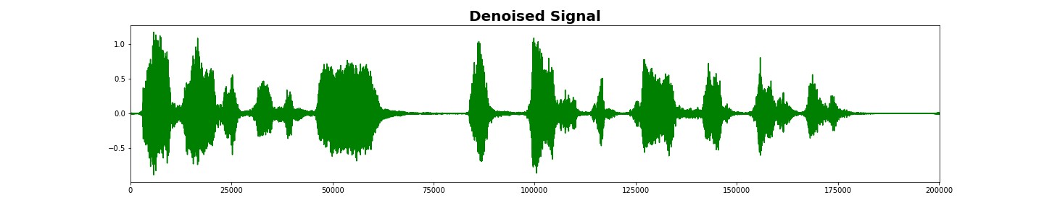

# References*:*

1. [**https://en.wikipedia.org/wiki/Fourier_analysis**](https://en.wikipedia.org/wiki/Fourier_analysis)
2. [**https://en.wikipedia.org/wiki/Noise_gate**](https://en.wikipedia.org/wiki/Noise_gate)
3. [**https://nl.wikipedia.org/wiki/Short-time_Fourier_transform**](https://nl.wikipedia.org/wiki/Short-time_Fourier_transform)
4. [**https://www.youtube.com/watch?v=spUNpyF58BY**](https://www.youtube.com/watch?v=spUNpyF58BY)
5. [**https://www.youtube.com/watch?v=3gjJDuCAEQQ**](https://www.youtube.com/watch?v=3gjJDuCAEQQ)